Homework VBA-Challenge

Federico Mendoza

VBA Code:

Sub tarea1()

For Each ws In Worksheets

ws.Select

Cells(1, 9) = "Ticker"

Cells(1, 10) = "Yearly change"

Cells(1, 11) = "Percent Change"

Cells(1, 12) = "Total stock volume"

Cells(2, 14) = "Greatest % Increase"

Cells(3, 14) = "Greatest % Decrease"

Cells(4, 14) = "Greatest Total volume"

Cells(1, 15) = "Ticker"

Cells(1, 16) = "Value"

Dim ticker As String

Dim voltotal As Double

Dim summary_row As Integer

Dim openstock As Double

Dim closestock As Double

Dim highstock As Double

Dim lowstock As Double

summary_row = 2

voltotal = 0

openstock = 0

closestock = 0

highstock = 0

lowstock = 0

LastRow = ws.Cells(Rows.Count, 1).End(xlUp).Row

For i = 2 To LastRow

If Cells(i + 1, 1).Value <> Cells(i, 1).Value Then

ticker = Cells(i, 1).Value

voltotal = voltotal + Cells(i, 7).Value

openstock = openstock + Cells(i, 3).Value

closestock = closestock + Cells(i, 6).Value

highstock = highstock + Cells(i, 4).Value

lowstock = lowstock + Cells(i, 7).Value

Cells(summary_row, 9) = ticker

Cells(summary_row, 12) = voltotal

Cells(summary_row, 10) = closestock - openstock

Cells(summary_row, 11) = FormatPercent(highstock / lowstock)

summary_row = summary_row + 1

voltotal = 0

openstock = 0

closestock = 0

Else

voltotal = voltotal + Cells(i, 7).Value

openstock = openstock + Cells(i, 3).Value

closestock = closestock + Cells(i, 6).Value

highstock = highstock + Cells(i, 3).Value

lowstock = lowstock + Cells(i, 6).Value

End If

Next i

Dim greatestincrease As Double

Dim greatestdecrease As Double

Dim greatestvol As Double

greatestincrease = Range("K2")

greatestdecrease = greatestincrease

greatestvol = Range("L2")

ticket1 = Range("I2")

ticket2 = ticket1

ticket3 = ticket1

LastRow = ws.Cells(Rows.Count, 9).End(xlUp).Row

For i = 2 To LastRow

If Cells(i, 10) <= 0 Then

Cells(i, 10).Interior.ColorIndex = 3

Else

Cells(i, 10).Interior.ColorIndex = 4

End If

If greatestincrease < Cells(i + 1, 11) Then

greatestincrease = Cells(i + 1, 11)

ticket1 = Cells(i + 1, 9)

Cells(2, 16) = FormatPercent(greatestincrease)

Cells(2, 15) = ticket1

End If

If greatestdecrease > Cells(i + 1, 11) Then

greatestdecrease = Cells(i + 1, 11)

ticket2 = Cells(i + 1, 9)

Cells(3, 16) = FormatPercent(greatestdecrease)

Cells(3, 15) = ticket2

End If

If greatestvol < Cells(i + 1, 12) Then

greatestvol = Cells(i + 1, 12)

ticket3 = Cells(i + 1, 9)

Cells(4, 16) = greatestvol

Cells(4, 15) = ticket1

End If

Next i

Next

End Sub

Sheet 1:

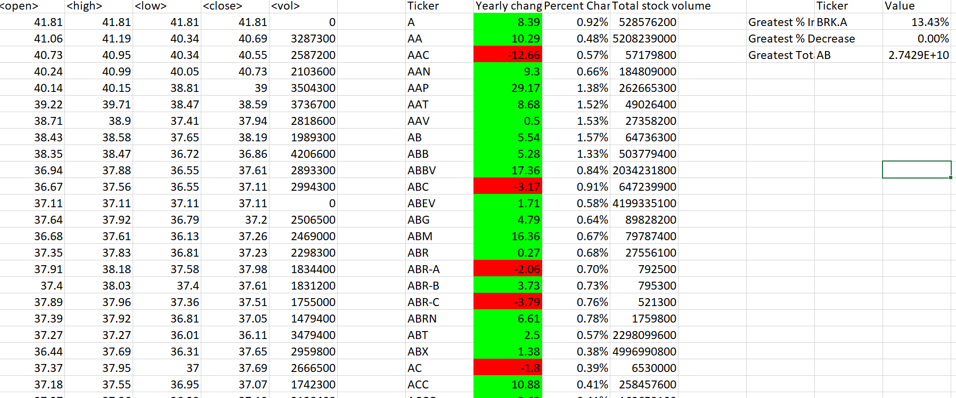

Sheet 2:

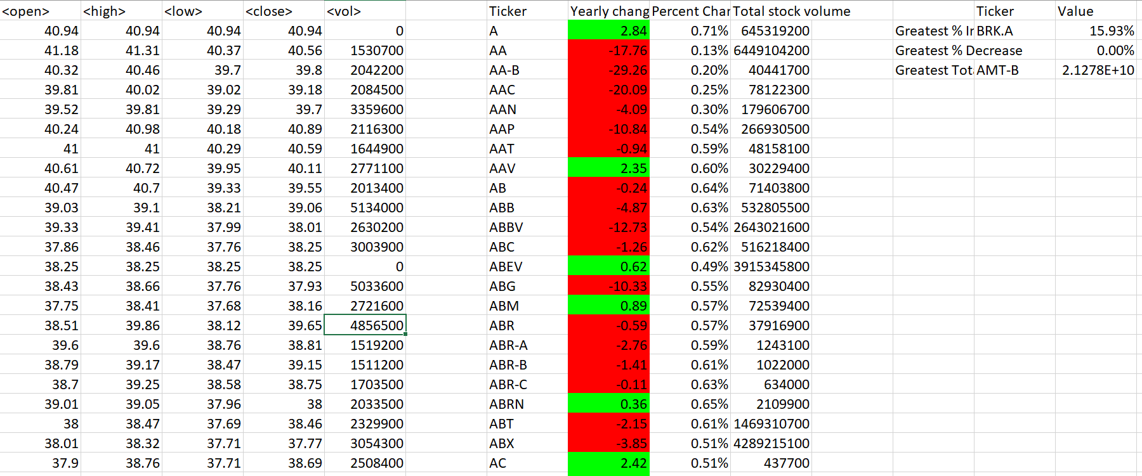

Sheet 3: